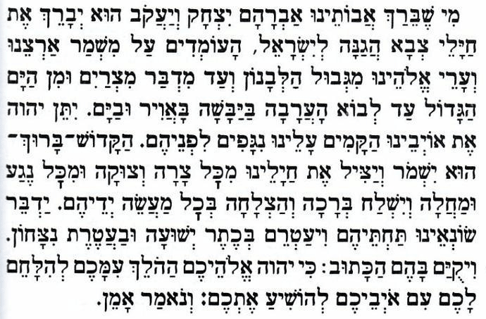

He Who blessed our forefathers Abraham, Isaac and Jacob -- may He bless the fighters of the Israel Defence Forces, who stand guard over our land and the cities of our God, from the border of the Lebanon to the desert of Egypt, and from the Great Sea unto the approach of the Aravah, on the land, in the air, and on the sea.
May the Almighty cause the enemies who rise up against us to be struck down before them. May the Holy One, Blessed is He, preserve and rescue our fighters from every trouble and distress and from every plague and illness, and may He send blessing and success in their every endeavour.
May He lead our enemies under our soldiers’ sway and may He grant them salvation and crown them with victory. And may there be fulfilled for them the verse: For it is the Lord your God, Who goes with you to battle your enemies for you to save you.

